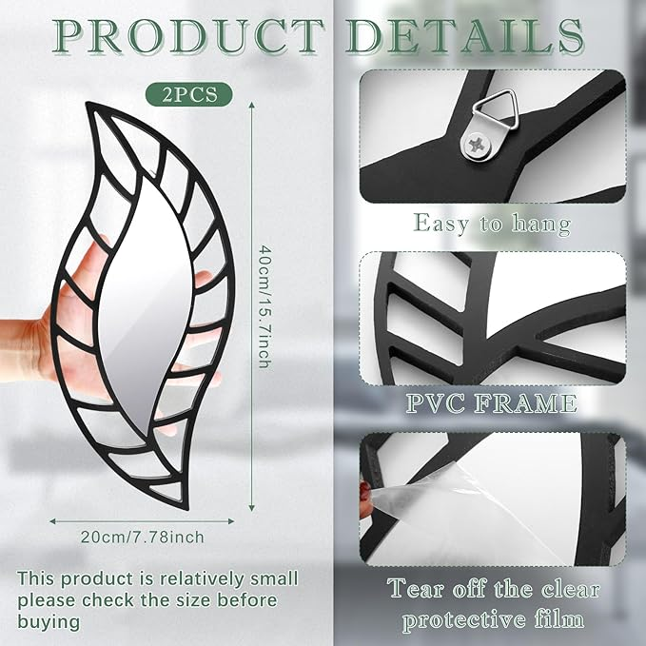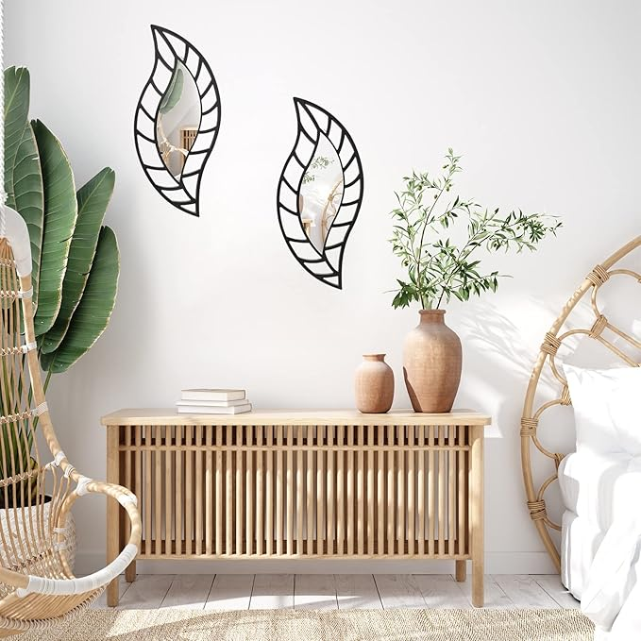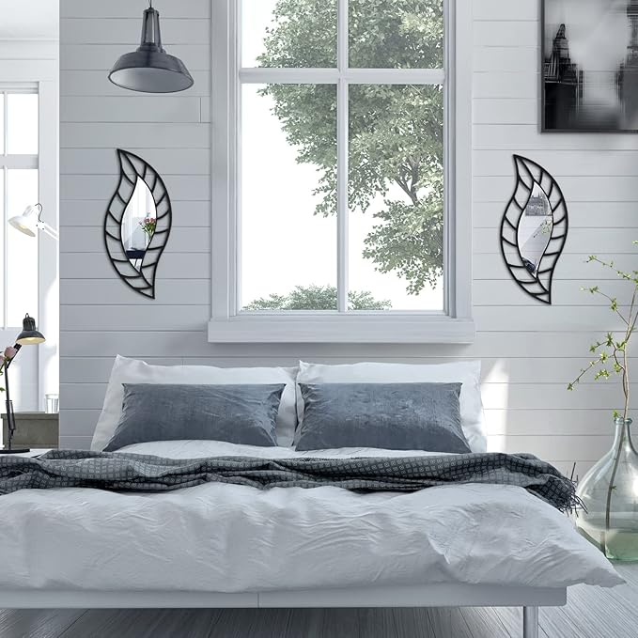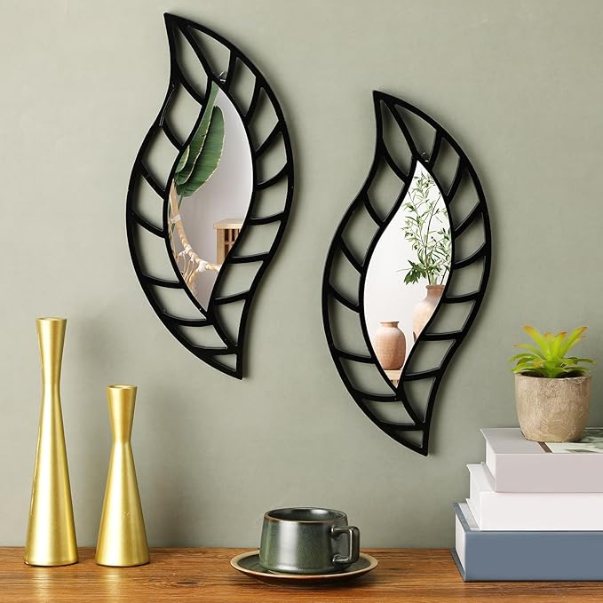

Roowest 2 Pcs Decorative Mirror Wall Decor Leaf Teardrop Mirror Wall Mounted Decorations for Living Room Bedroom Bathroom Vanity Entryway Office(Black)

**PRODUCT DESCRIPTION:**

|  |  |
| --- | --- |
| Brand | Roowest |
| Room Type | Living Room |
| Shape | Leaf |
| Product Dimensions | 15.75"L x 7.87"W |
| Frame Material | Wood |

**About this item**

* Leaf Shaped Mirror: you will receive 2 pieces of leaf decorative wall mirrors, and our delicate wall mirrors come with triangular hooks on the back that you can attach them to the wall using the screws, both vertical and horizontal hangings are available; There's a clear protective film on the surface to avoid scratches while transportation, please peel off it before using
* Noticeable Size: our irregular wall mirror measures about 15.75 x 7.87 inches/ 40 x 20 cm in length and width, and 0.39 inches/ 1 cm in thickness, the size design makes them easily noticed when guests come to visit your house, and meanwhile they will not take up a lot of space
* Stylish and Modern: this wall mirror decor is decorated with a combination of leaf frame and reflective mirror, with simple lines and layered textures that add character and sophistication to the design, leaf mirror hangings are a harmonious way to add a touch of beauty and romance to any space
* Built to Last Long: our rustic mirrors for wall decor are mainly made of acrylic and PVC materials with wood frame, the mirror surface is reflective, making your room brighter, and the wood and PVC material will enhance the robustness and durability of the mirror
* Wide Range of Use: this leaf dining room wall decor can be applied to most smooth and clean surfaces such as wall, doors, windows, closets and more for living room, bedroom, kitchen, home, office, porch, entryway, hallway, porch, stairs and so on